SDLC Phase 2 – System Design

TITLE: Vehicle Parking Slot Reservation System

PROJECT MEMBERS:
Minendhar sara
Seetha reddy gorrepati
Mahesh reddy kommasani

1.High-Level System Architecture

The system follows a three-tier web architecture consisting of a Frontend (User Interface), Backend (Application Logic), and Database (Data Storage). Users access the system through a web browser. The frontend communicates with the backend via HTTP requests, and the backend interacts with the database to retrieve or store information.
Architecture Diagram:
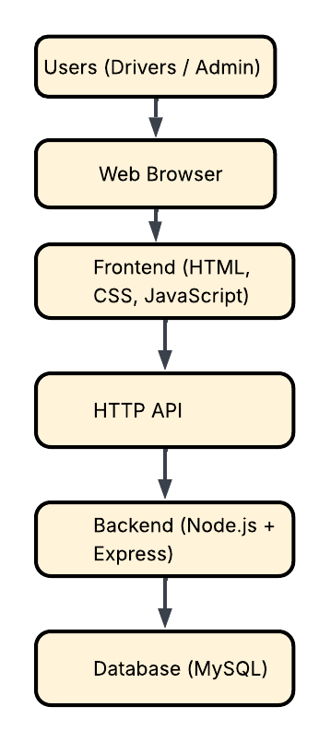
Data Flow
- Users access the system via a browser.
- The frontend sends requests to the backend API.
- The backend processes logic such as authentication and reservations.
- The database stores and retrieves system data.
- Results are returned to the frontend and displayed to users.

2.Component Description

Frontend
The frontend handles all user interaction and interface display.
Responsibilities:
- User registration and login forms
- Display parking slot availability
- Reservation interface
- Dashboard for users and administrators
Communication:
The frontend communicates with the backend using REST API calls over HTTP.
Example APIs:
POST /register
POST /login
GET /slots
POST /reserve
DELETE /reservation

Backend
The backend contains the core application logic and processes requests from the frontend.
Responsibilities:
- Authentication and user verification
- Reservation processing
- Prevent double booking
- Input validation
- Managing parking slot availability
Technology used:
Node.js with Express framework

Database
The database stores all system data.
Stored Data:
- User accounts
- Parking slots
- Reservation records
- Reservation times and statuses
Database choice: MySQL
Reason:
MySQL is reliable for structured relational data and supports relationships between users, slots, and reservations.

3. Data Model (Class Diagram)
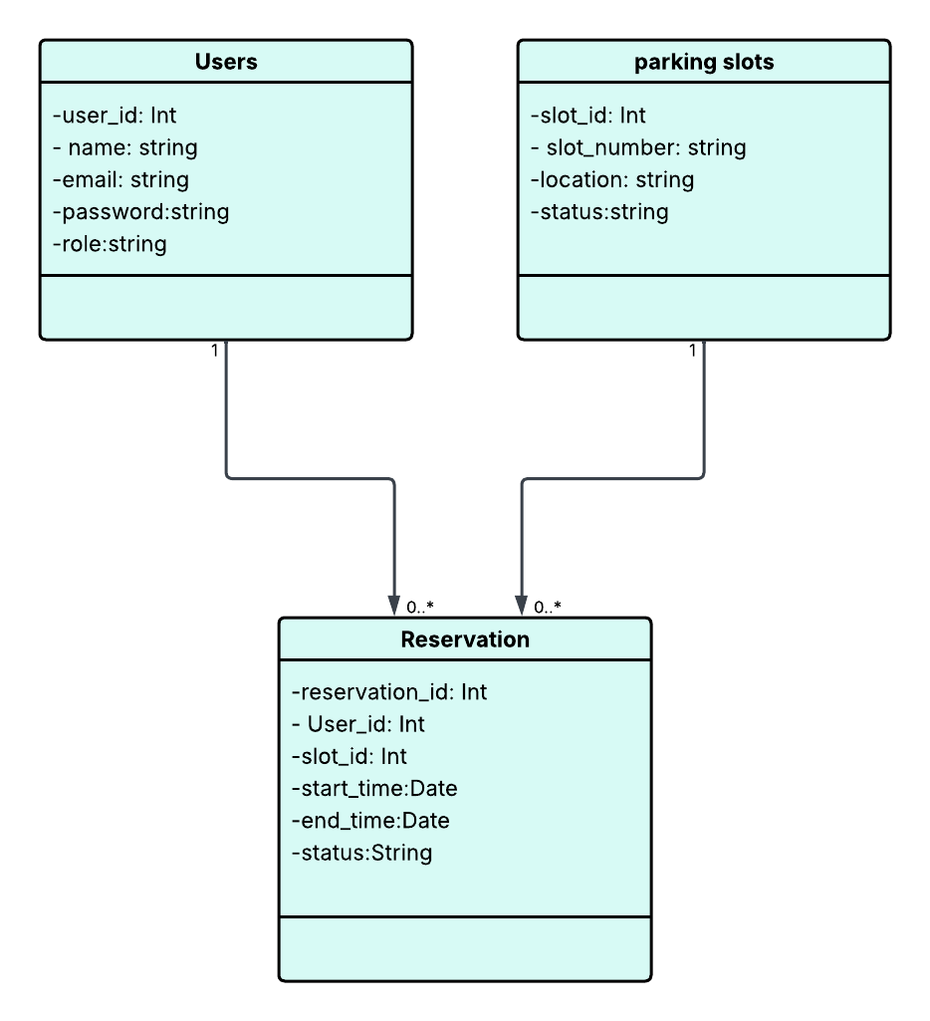
Relationships:
- One User can have many Reservations.
- One Parking Slot can have many Reservations over time.
- Reservation links a user to a parking slot.

4. UI Wireframes (Low-Fidelity)

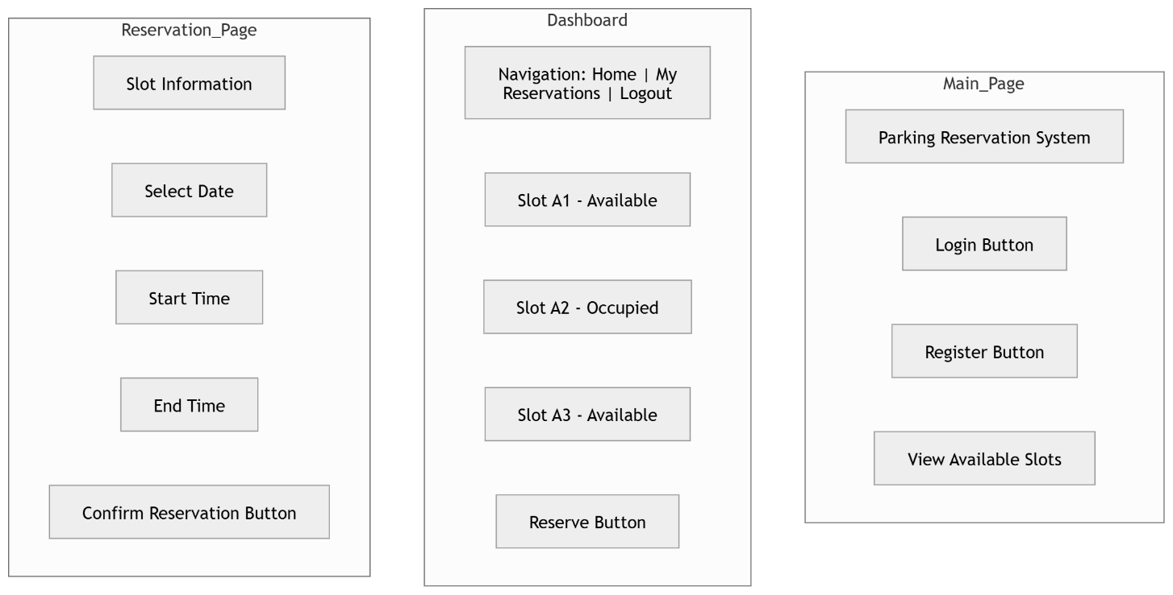

5. Technology Stack Justification

Frontend
HTML, CSS, JavaScript
Reason:
- Simple and widely supported
- No cost
- Suitable for small projects
Backend
Node.js with Express
Reason:
- Efficient for API development
- Handles multiple users
- Large ecosystem of libraries
Database
MySQL
Reason:
- Structured relational storage
- Reliable data relationships
- Good for reservation systems
Why this stack:
We chose HTML/CSS/JS for the frontend, Node.js + Express for the backend, and MySQL for the database because they are easy to use, widely supported, and free, making them suitable for a 12-week student project.
How it supports requirements:
- Frontend: Simple, responsive interface for login, dashboards, and reservations.
- Backend: Handles authentication, reservations, and prevents double-booking efficiently.
- Database: Relational storage ensures proper tracking of users, slots, and reservations.
Trade-offs considered:
- MySQL is less flexible than NoSQL but better for relational data.
- Using plain JS instead of frameworks like React is faster to develop but less scalable.
- Free hosting may limit concurrency, but it fits the project’s budget and scope.

